**Contd from solace cli command……**

Define message-spool

enable

config

**message-spool message-vpn change-message-vpn**

**create queue queuecli02**

**Max-spool-usage 100**

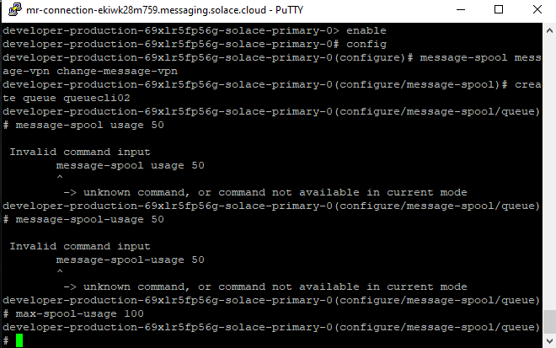

**permission all consume**

**no shut**

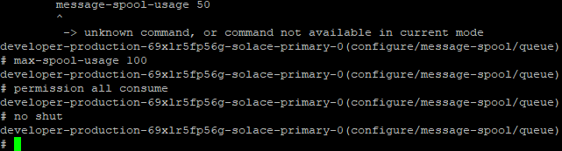

**show queue \***

**show queue queucli02 detail**

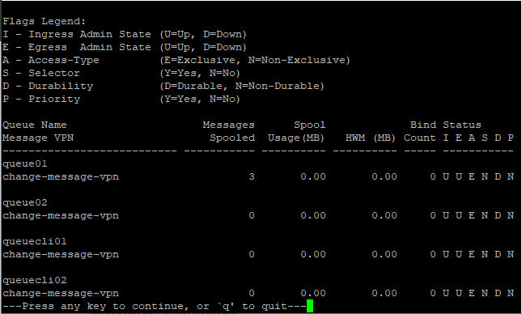

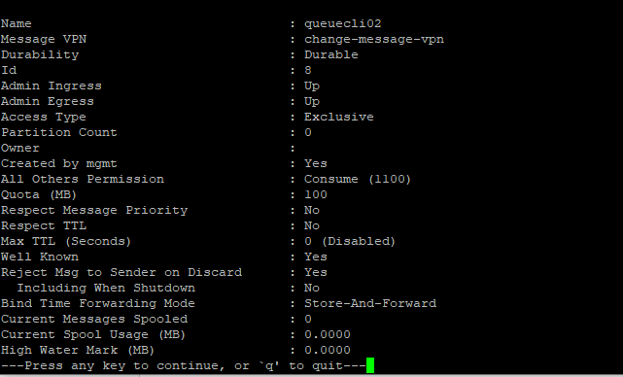

**Session restart→ getting into queuecli02**

**enable**

**config**

**message-spool message-vpn change-message-vpn**

**queue queuecli02**

**subscription topic hellocli2 (to create a topic in subscription)**

